**TIC TAC TOE GAME**

**Aim :** The goal of the game is for players to position their marks so that they make a continuous line of three cells **vertically, horizontally**, or **diagonally**

**Working of tic tac toe:**

**Functions used:**

**Board() :** to draw aboard like structure 3x3 matrix to mark either ‘X’ or ‘O’

**Checkwin() :** this function return 1 if any of the possible winning combination happened like row,column or diagonal.

And returns -1 if even a single block is still the number Eg : 1,2…upto 9.

And return 0 if none of the above are satisfied.

**Sample Inputs and Outputs:**

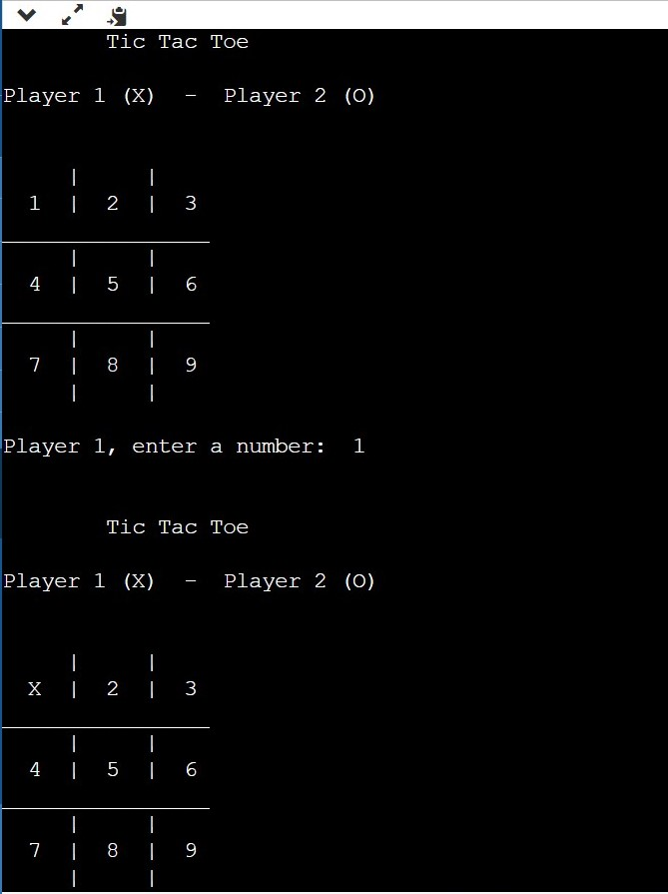 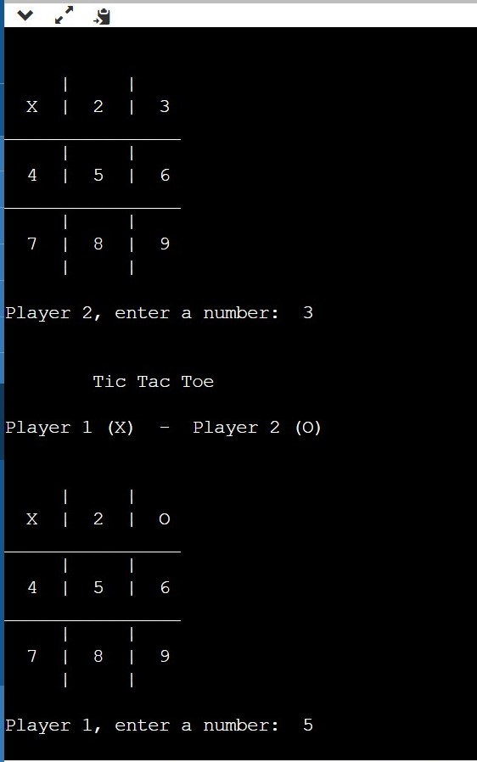

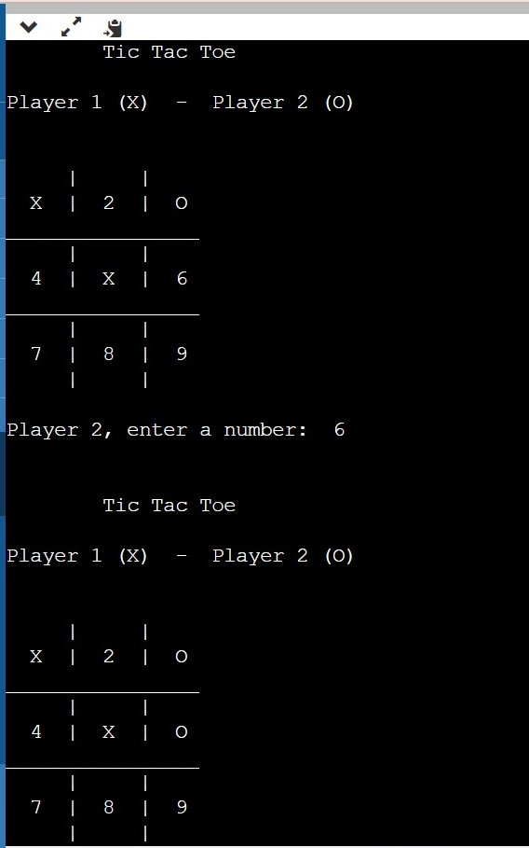 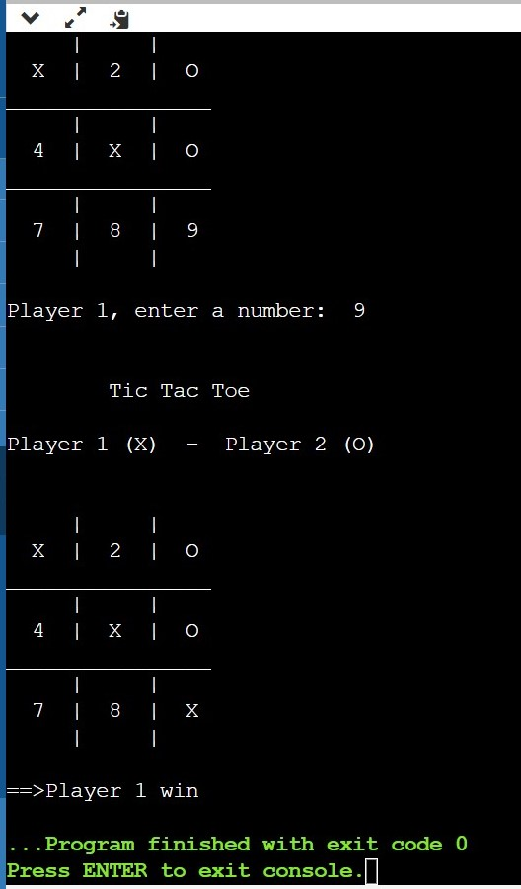

**Main method working:**

* There is a do while loop in the main method first in the do while board() function is called which is used to make a 3x3 board figure
* This do while loop will run until a variable i which contains the return value from checkwin() function the loop will run until the I value is equals to -1
* The checkwin() function return -1 if no possible winning combination is met and atleast one of the block is not marked it actually return -1 till 3-4 steps like as shown in the input
* There is a player variable which gives chance evenly to both the players denoted by %2 used ternary condition at first it return 1 and then 2 which are used to take input from both the players
* And then there is a mark variable which is the main to mark the ‘X’ and ‘O’ if player value equal to 1 then it marks ‘X’ if it is 2 then it marks ‘O’
* There is an if-else-if ladder which contains the values from 1 to 9 specifying each and every block the mark will be replaced by its block number according to the input taken from the player respectively.
* If there any number greater than 9 or less than 1 then the chance of the player is lost and the chance goes to the other player
* If any winning matches then checkwin() function returns 1 then the do while loop stops and prints the winned players number Eg: player 1 or player 2

**CODE:**

#include <stdio.h>

#include <conio.h>

char square[10] = { '0', '1', '2', '3', '4', '5', '6', '7', '8', '9' };

/***********************

FUNCTION TO DRAW BOARD OF TIC TAC TOE WITH PLAYERS MARK

************************/

void board()

{

// system("cls");

printf("\n\n\tTic Tac Toe\n\n");

printf("Player 1 (X) - Player 2 (O)\n\n\n");

printf(" | | \n");

printf(" %c | %c | %c \n", square[1], square[2], square[3]);

printf("________________\n");

printf(" | | \n");

printf(" %c | %c | %c \n", square[4], square[5], square[6]);

printf("________________\n");

printf(" | | \n");

printf(" %c | %c | %c \n", square[7], square[8], square[9]);

printf(" | | \n\n");

}

int checkwin();

int main()

{

int player = 1, i, choice;

char mark;

do

{

board();

player = (player % 2) ? 1 : 2;

printf("Player %d, enter a number: ", player);

scanf("%d", &choice);

mark = (player == 1) ? 'X' : 'O';

if (choice == 1 && square[1] == '1')

square[1] = mark;

else if (choice == 2 && square[2] == '2')

square[2] = mark;

else if (choice == 3 && square[3] == '3')

square[3] = mark;

else if (choice == 4 && square[4] == '4')

square[4] = mark;

else if (choice == 5 && square[5] == '5')

square[5] = mark;

else if (choice == 6 && square[6] == '6')

square[6] = mark;

else if (choice == 7 && square[7] == '7')

square[7] = mark;

else if (choice == 8 && square[8] == '8')

square[8] = mark;

else if (choice == 9 && square[9] == '9')

square[9] = mark;

else

{

printf("Invalid move ");

player--;

getch();

}

i = checkwin();

player++;

}while (i == - 1);

board();

if (i == 1)

printf("==>\aPlayer %d win ", --player);

else

printf("==>\aGame draw");

getch();

return 0;

}

/***************

FUNCTION TO RETURN GAME STATUS

1 FOR GAME IS OVER WITH RESULT

-1 FOR GAME IS IN PROGRESS

O GAME IS OVER AND NO RESULT

****************/

int checkwin()

{

if (square[1] == square[2] && square[2] == square[3])

return 1;

else if (square[4] == square[5] && square[5] == square[6])

return 1;

else if (square[7] == square[8] && square[8] == square[9])

return 1;

else if (square[1] == square[4] && square[4] == square[7])

return 1;

else if (square[2] == square[5] && square[5] == square[8])

return 1;

else if (square[3] == square[6] && square[6] == square[9])

return 1;

else if (square[1] == square[5] && square[5] == square[9])

return 1;

else if (square[3] == square[5] && square[5] == square[7])

return 1;

else if (square[1] != '1' && square[2] != '2' && square[3] != '3' &&

square[4] != '4' && square[5] != '5' && square[6] != '6' && square[7]

!= '7' && square[8] != '8' && square[9] != '9')

return 0;

else

return - 1;

}